**Basic Commands of Hadoop (PART-1)**

* **To check whether all the daemons are working or not.**

Command: jps

Description: When you run Hadoop on any machine, you can look at the specific processes of Hadoop through one of the utilities provided by Java called the JPS (Java Virtual Machine Process Status) tool.

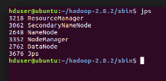Output:

* **To know the contents or list of contents.**

Command: hadoop fs -ls 🡪 to know list of contents in the hadoop home directory.

Command : hadoop fs -ls / 🡪to know list of contents in the hadoop root directory.

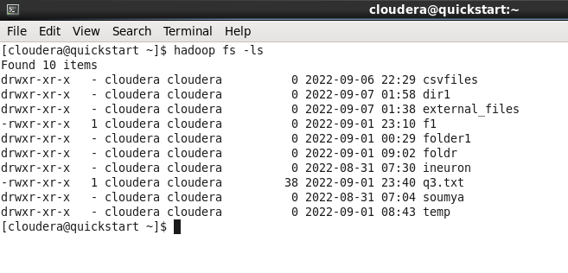 Output 1:

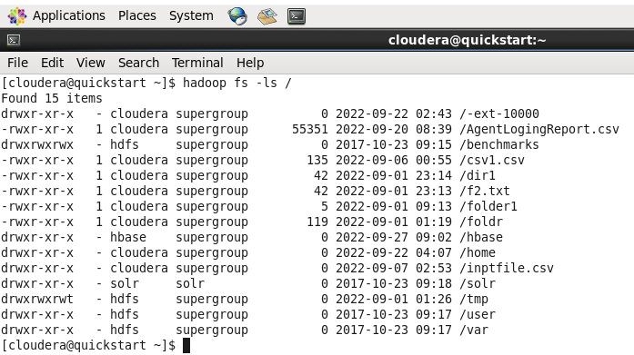 Output 2:

* **If we want to list the contents for a particular directory.**

Command: hadoop fs -ls /directoryname

Output:



* **If we want to create a directory .**

Command: hadoop fs -mkdir directoryname

Output:

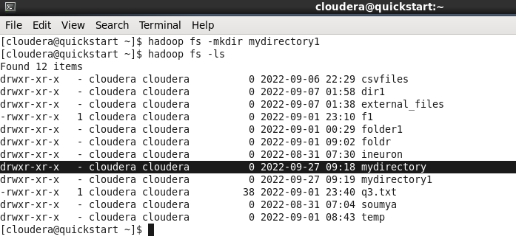

* **To create an empty file of any format.**

Command: hadoop fs -touchz filename

Output:

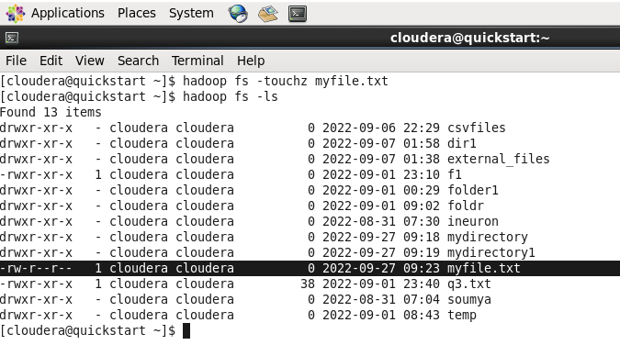

* **To Copy data from the local system**

Command: hadoop fs -copyFromLocal filelocation to hadoop system(location) (OR)

hadoop fs -put filelocation to hadoop system(location)

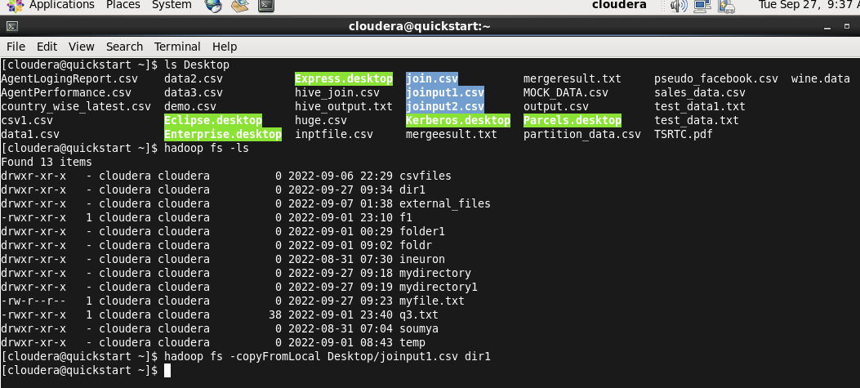 Output:

* **To copy files from hadoop file system to local system.**

Command: hadoop fs -copyToLocal filelocation to required location. (OR)

hadoop fs -get filelocation to required location.

Output:

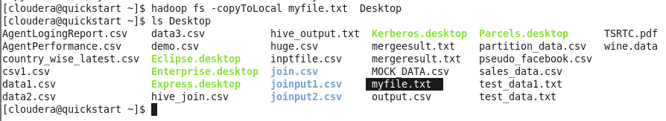

* **To display the contents of the file.**

Command: hadoop fs -cat filelocation

Output:

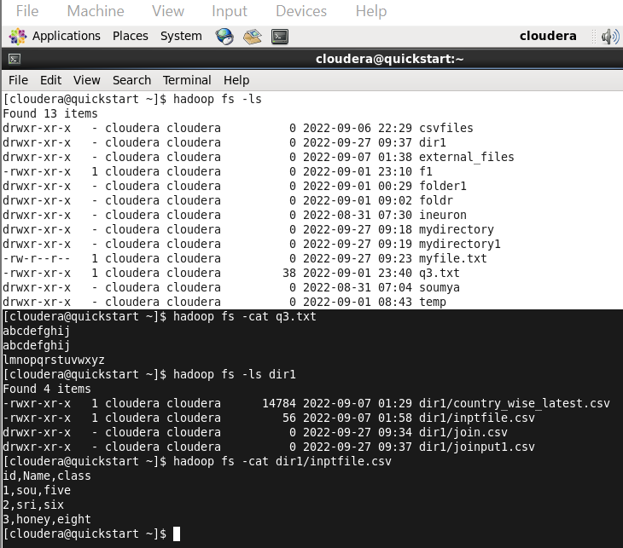

* **To copy file between local system and hadoop file system.**

Command: hadoop fs -cp filelocation(to be transfered) location(file to be saved)

Output:

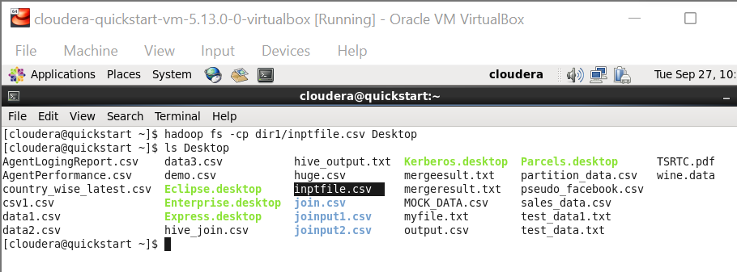

* **To move file from one directory to another directory or between local and hadoop systems.**

Command: hadoop fs -mv filelocation(to be transferred) location(file to be saved)

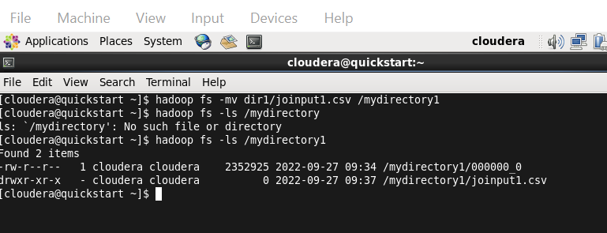 Output:

* **To check the disk usage of any directory.**

Command: hadoop fs -du directoryname

Output :

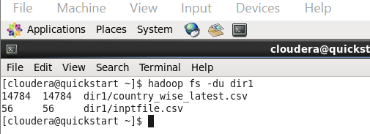

* **To check the disk usage of the entire directories at one place.**

Command: hadoop fs -dus directoryname

Output:

